E-paper Display

Raw Panels:

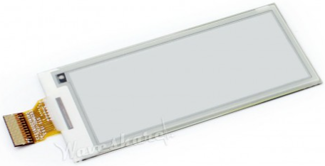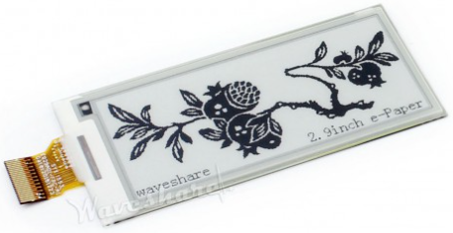

Adapter:

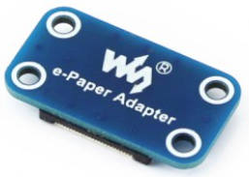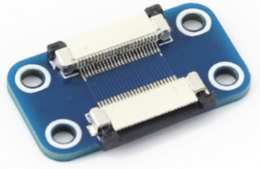

Driver:

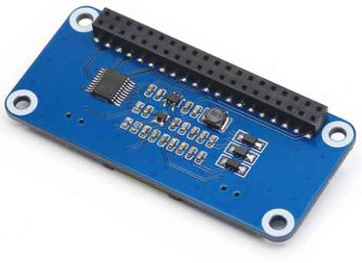

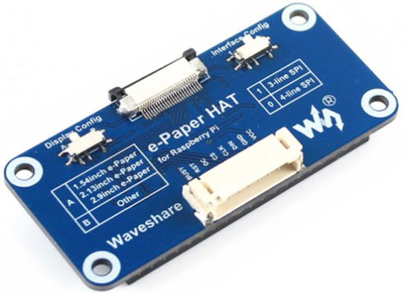

Dimensions:

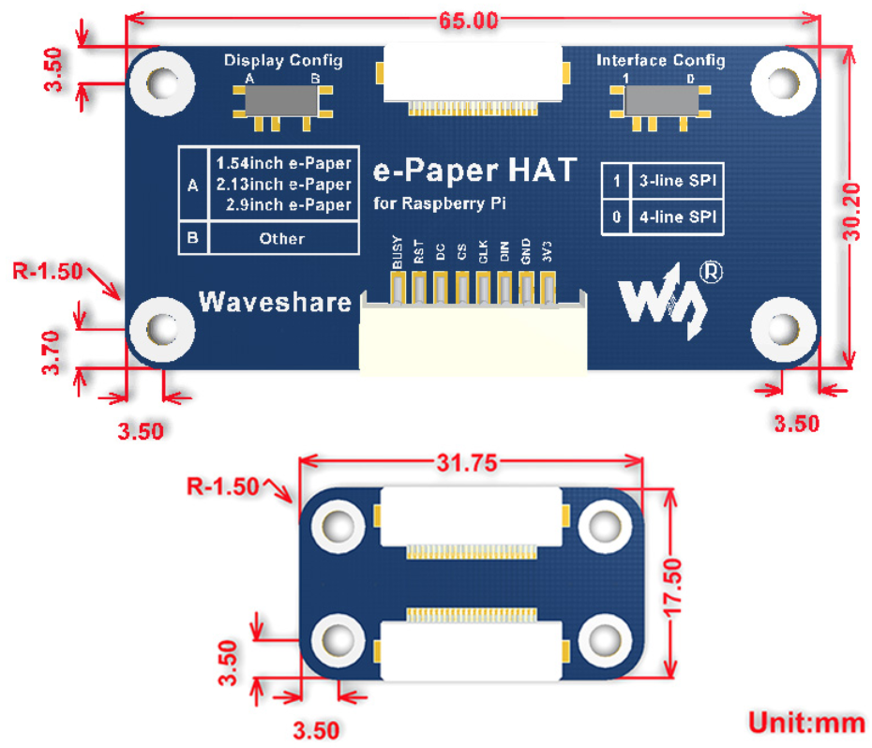

SCHEMATICS:

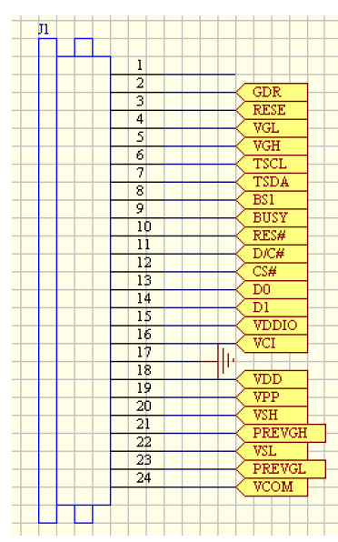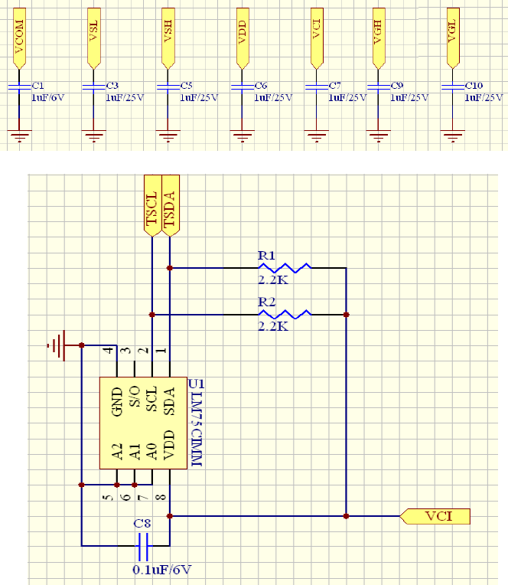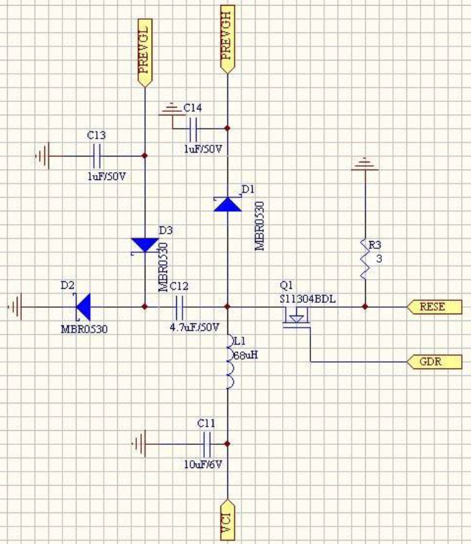

REFERENCES:

* [296x128, 2.9inch E-Ink raw display, SPI interface, without PCB | E029A01-FPCA-V2.0 E029A01-FPC-A1 (waveshare.com)](https://www.waveshare.com/2.9inch-e-paper.htm)
* [Universal e-Paper Driver HAT, supports various Waveshare SPI e-Paper raw panels](https://www.waveshare.com/e-Paper-Driver-HAT.htm)